What is shell Scripting?

* Shell scripting is basically a scrip that contains series of command which is used to perform a particular task, Shell scripting is basically executed in a sequential manner.
* Shell Scripting is mostly used for automation purposes

Basic Shell Script example

#!/bin/bash 🡪 is called as the Shebang (it is used to tell the OS which interpreter you will be using) (**Its not mandatory to use the shebang**)

Sending Output to the terminal  
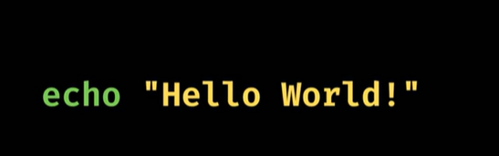

How to execute a shell script

Comments in shell Scripting

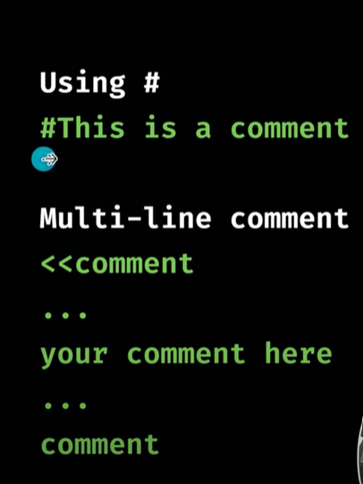

Variables in Shell Scripting  
  
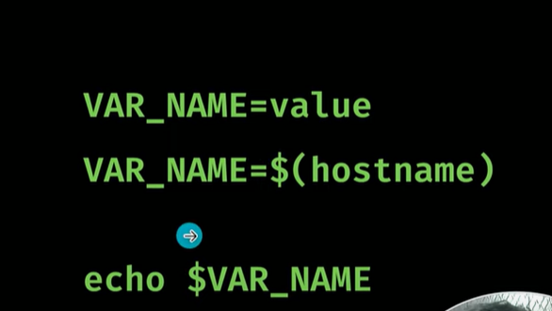

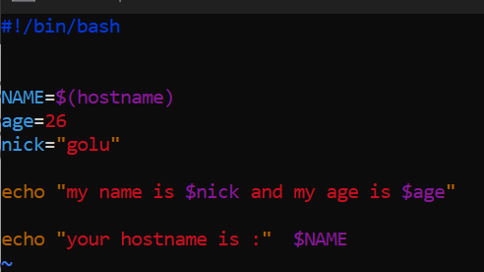

What is Constant variable?

One the value for a variable is declared then it cannot be changes, you just need to add the (readonly) term before your variable

Readonly name=”Rohit”

**Taking Inputs from the USER**

Read -p (p is used to print someting)

CONDITIONAL STATEMENT IN SHELL

1. IF – ELSE

1. ELIF

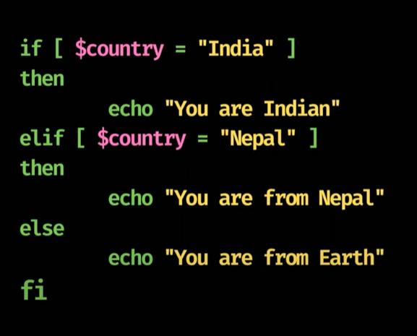

NOTE: When you are dealing with number you can use  **-eq**  and when you are dealing with string you can use the **=** symbol  
  
**=**: This is used for string comparison. It checks if two strings are equal. For example:

**-eq**: This is used for numerical comparison. It checks if two numbers are equal. For example:

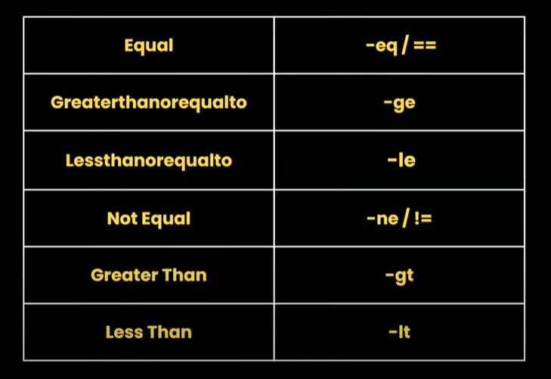

How to add two conditions

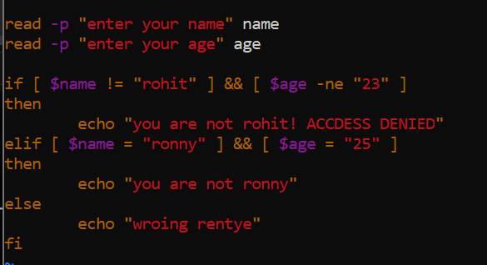

Check if file or directory exist

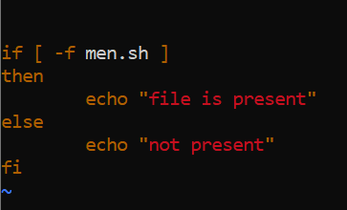

Swithc case

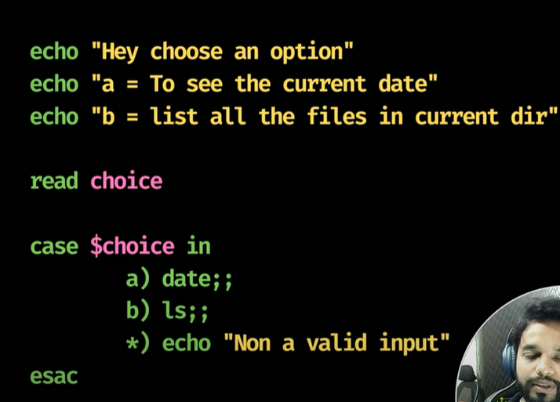

* Is the default case (*), if no condition is met

For LOOP

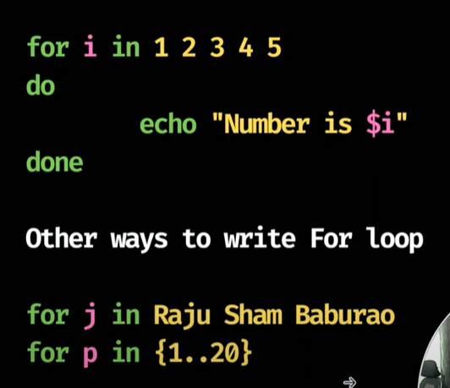

How to take valued from a file

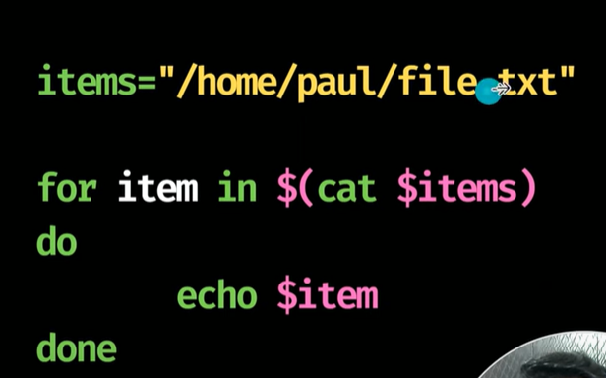

While loop

Until loop

The until loop will run till that time when the condition become false(opposite of while loop)

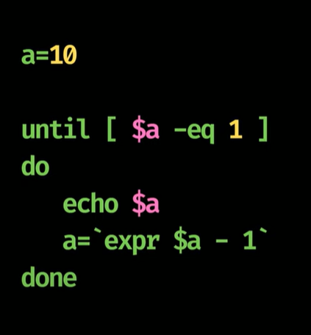

HOW TO USE EXPRESSION

HOW TO PRINT THE NAME OF THE SCRIPT

Functions in Shell Scripting

There are two ways to create a function in the shell scripting

1 function func() {}

2 myfun() {}

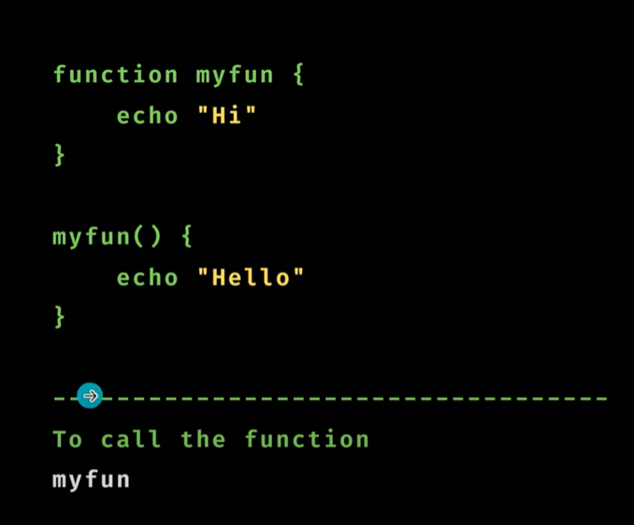

We can pass argument in functions as well

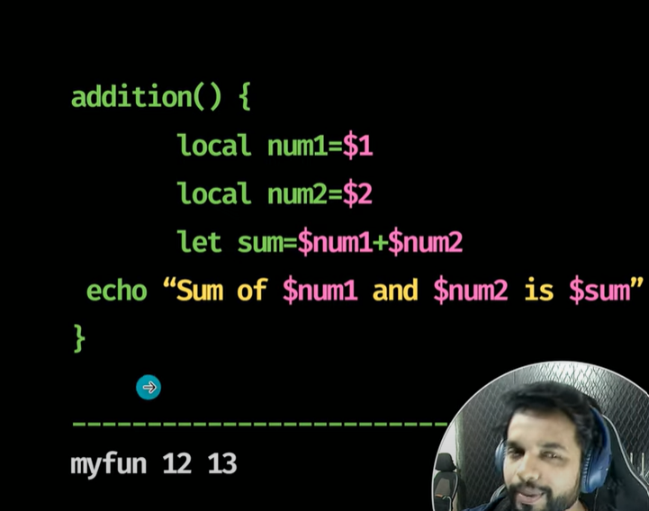

PARAMETERS

* **positional Parameters ($0, $1, $2, ...):**
  + $0 holds the name of the script itself.
  + $1, $2, $3, and so on, represent the first, second, third, and subsequent command-line arguments, respectively.
  + For arguments beyond $9, use curly braces, such as ${10} for the tenth argument.
* **Special Parameters:**
  + $#: Contains the total number of command-line arguments passed to the script (excluding the script name).
  + $@: Represents all command-line arguments as separate strings, preserving individual arguments even with spaces (e.g., for arg in "$@"; do ...).
  + $*: Represents all command-line arguments as a single string, where arguments are joined by the first character of IFS (Internal Field Separator), typically a space. When enclosed in double quotes ("$*"), it treats all arguments as a single argument.
  + $? is a special parameter that holds the exit status of the most recently executed foreground command or pipeline.

Example Usage:

Consider a script named greet.sh:

Code

*#!/bin/bash*  
echo "Hello, $1!"  
echo "You passed $# arguments."  
echo "All arguments: $@"

Executing greet.sh John Doe:

* $0 would be greet.sh
* $1 would be John
* $2 would be Doe
* $# would be 2
* $@ would expand to "John" "Doe"
* $* would expand to "John Doe"

BASH VARIABLE

RANDON- prints random values between 0 – 32,607

UID- prints the user id

If you don’t want to print any output on terminal, you can use /dev/null

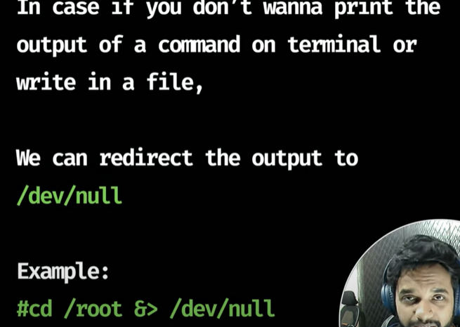

Logger

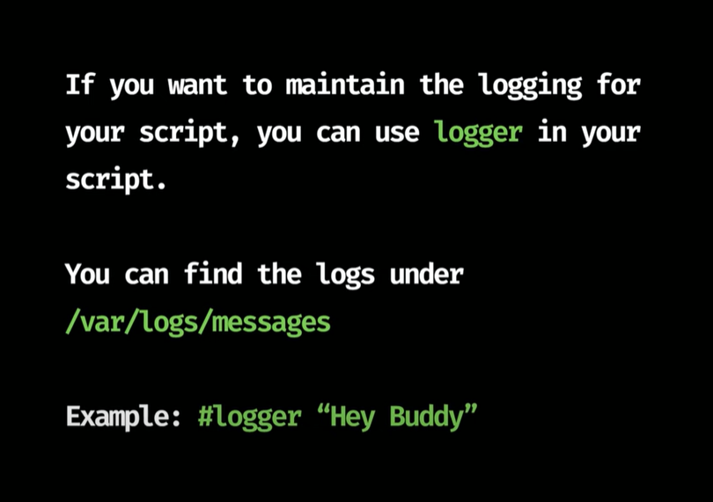

DEBUGGING SCRIPT

